**/*Write a C program to work with a square matrix of integers. The program should compute the sum of the primary diagonal, the secondary diagonal, and the difference between these sums. Additionally, incorporate multiple conditions and extended functionality for complexity.**

Detailed Requirements:

**1. Matrix Input:**

⦁ Accept the order of the square matrix (N) as input from the user.

⦁ The size of the matrix must be between 3x3 and 20x20, inclusive. Validate the input and prompt until a valid size is entered.

⦁ Populate the matrix with integer values entered by the user. Allow negative integers as well.

2. Primary and Secondary Diagonal Definitions:

⦁ Primary Diagonal: Elements where the row index equals the column index (matrix[i][j]).

⦁ Secondary Diagonal: Elements where the row index and column index sumto [N - 1]matrix[i][N−i−1]).

**3. Computations:**

⦁ Compute the sum of the primary diagonal.

⦁ Compute the sum of the secondary diagonal.

⦁ Compute the absolute difference between these two sums.

⦁ Identify and list common elements (if any) between the primary and secondary diagonals.

**4. Output Requirements:**

⦁ Display the input matrix in a properly formatted grid.

⦁ Display the computed sums for the primary diagonal, secondary diagonal, and their absolute difference.

⦁ If there are common elements, display them; otherwise, display "No common elements found between diagonals.".

**5. Additional Functionality:**

⦁ Highlight the primary and secondary diagonal elements in the displayed matrix by marking them with an asterisk (*).

⦁ Compute and display the total sum of non-diagonal elements in the matrix.

⦁ Allow the user to enter another matrix and repeat the process without restarting the program.

**6. Edge Case Handling:**

⦁ If all elements of a diagonal are zero, ensure the program clearly indicates that the diagonal sum is zero.

⦁ Handle matrices where primary and secondary diagonals do not overlap without error.

Example Execution:

**Input:**

⦁ Matrix Order (N): 4

⦁ Matrix Elements:

1 2 3 4

5 6 7 8

9 10 11 12

13 14 15 16

**Processing:**

⦁ Primary Diagonal: 1,6,11,16

Sum = 1+6+11+16=34

⦁ Secondary Diagonal: 4,7,10,13

Sum = 4+7+10+13=34

⦁ Absolute Difference: ∣34−34∣=0

⦁ Common Elements: ∅ ("No common elements").

⦁ Non-Diagonal Elements Sum: 2+3+5+8+9+12+14+15 = 68

**Output:**

⦁ Matrix with Diagonals Highlighted:

*1 2 3 *4

5 *6 *7 8

9 *10 *11 12

*13 14 15 *16

**⦁Results:**

⦁Primary Diagonal Sum: 34

⦁Secondary Diagonal Sum: 34

⦁Absolute Difference: 0

⦁ Non-Diagonal Elements Sum: 68

⦁ Common Elements: No common elements found*/

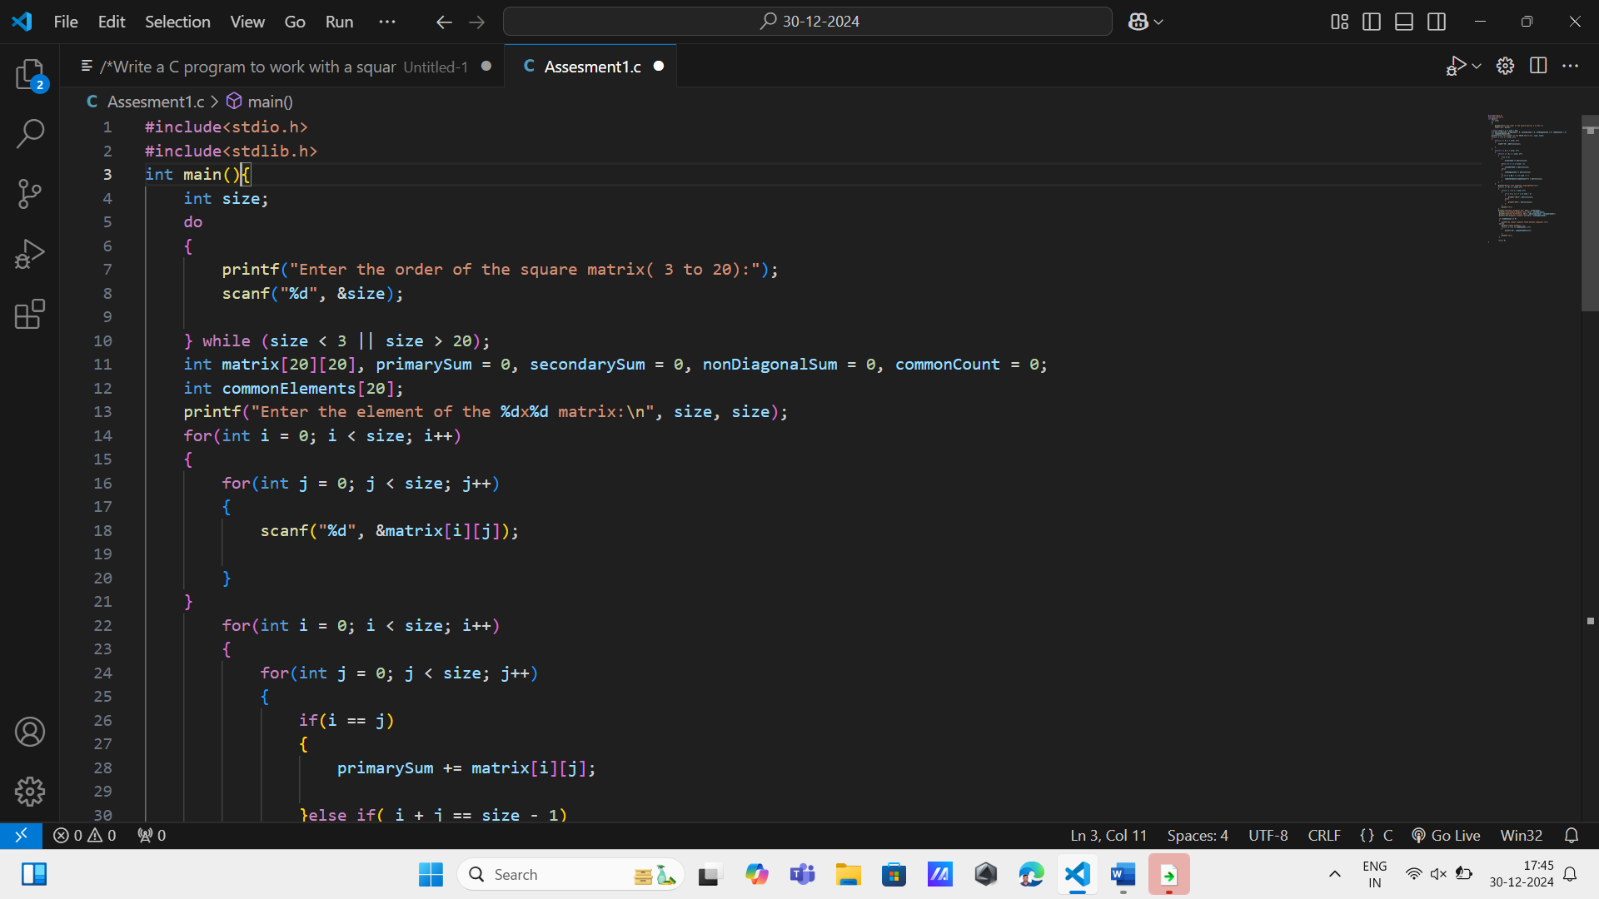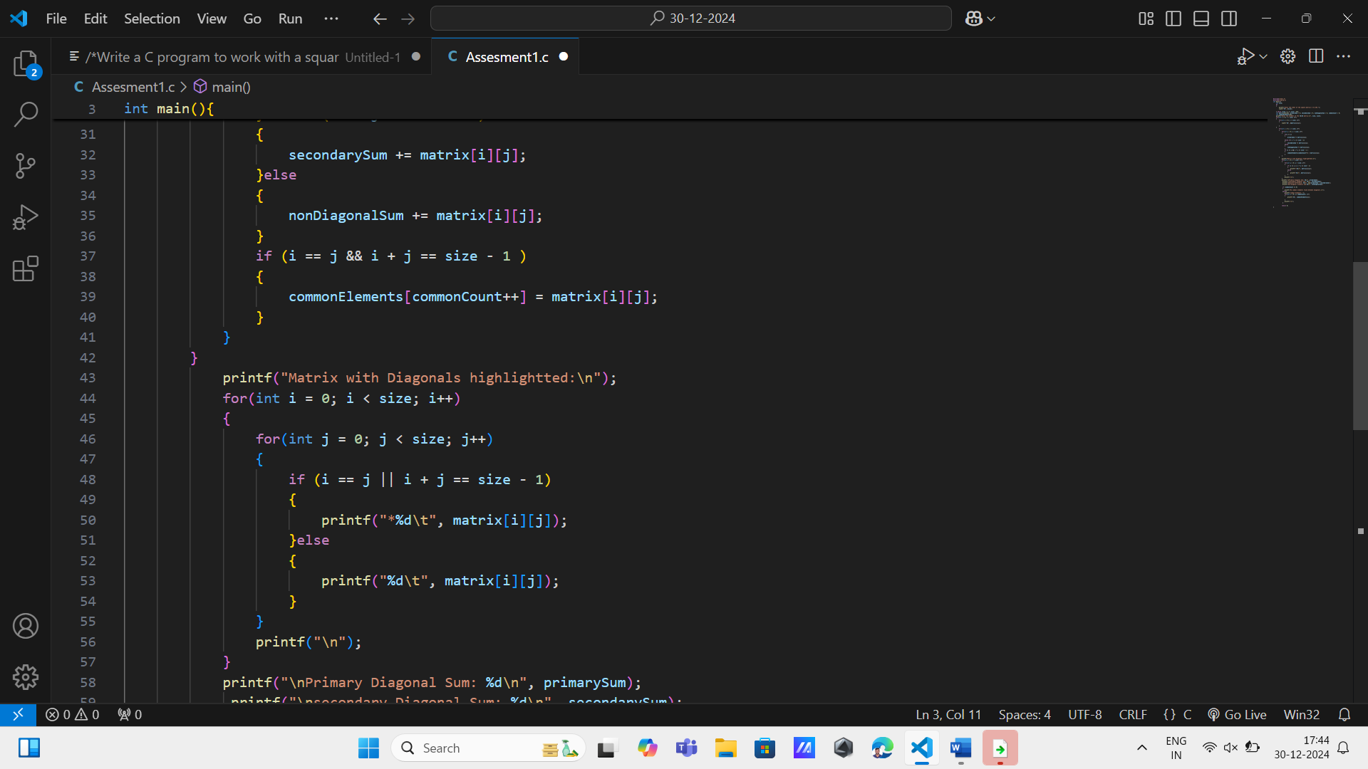

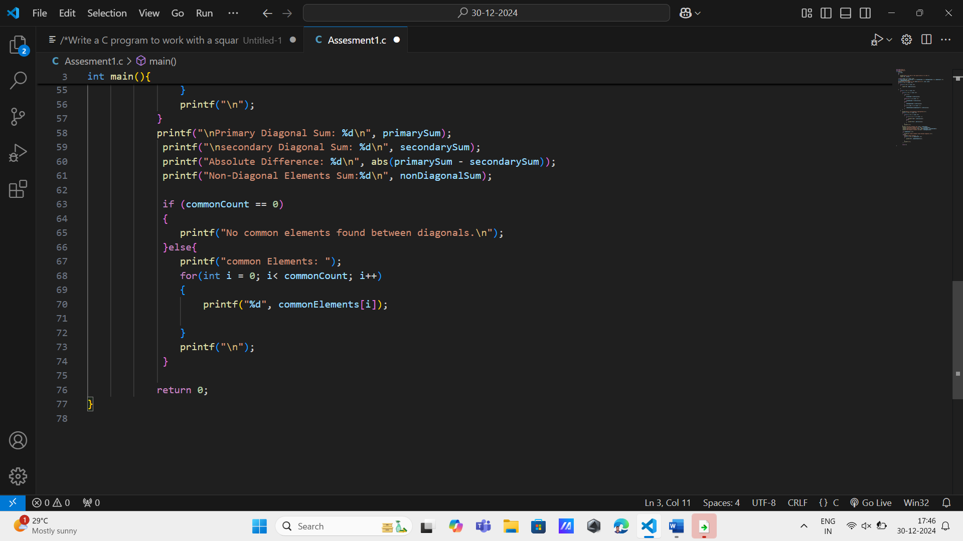**OUTPUT:-**

